# Model and Diagram

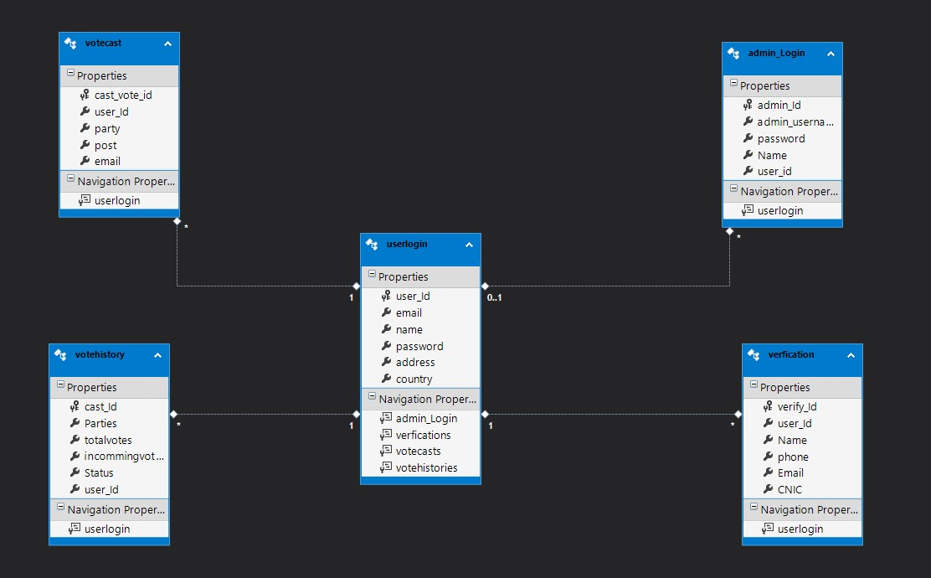

**Figure 1: Model Diagram**

# Controller Code

## Admin Login Controller

using System;

using System.Collections.Generic;

using System.Data;

using System.Data.Entity;

using System.Data.Entity.Infrastructure;

using System.Linq;

using System.Net;

using System.Net.Http;

using System.Web.Http;

using System.Web.Http.Description;

using WebApplication1.Models;

namespace WebApplication1.Controllers

{

public class admin_LoginController : ApiController

{

private vote_databaseEntities3 db = new vote_databaseEntities3();

// GET: api/admin_Login

public IQueryable<admin_Login> Getadmin_Login()

{

return db.admin_Login;

}

// GET: api/admin_Login/5

[ResponseType(typeof(admin_Login))]

public IHttpActionResult Getadmin_Login(int id)

{

admin_Login admin_Login = db.admin_Login.Find(id);

if (admin_Login == null)

{

return NotFound();

}

return Ok(admin_Login);

}

// PUT: api/admin_Login/5

[ResponseType(typeof(void))]

public IHttpActionResult Putadmin_Login(int id, admin_Login admin_Login)

{

if (!ModelState.IsValid)

{

return BadRequest(ModelState);

}

if (id != admin_Login.admin_Id)

{

return BadRequest();

}

db.Entry(admin_Login).State = System.Data.Entity.EntityState.Modified;

try

{

db.SaveChanges();

}

catch (DbUpdateConcurrencyException)

{

if (!admin_LoginExists(id))

{

return NotFound();

}

else

{

throw;

}

}

return StatusCode(HttpStatusCode.NoContent);

}

// POST: api/admin_Login

[ResponseType(typeof(admin_Login))]

public IHttpActionResult Postadmin_Login(admin_Login admin_Login)

{

if (!ModelState.IsValid)

{

return BadRequest(ModelState);

}

db.admin_Login.Add(admin_Login);

try

{

db.SaveChanges();

}

catch (DbUpdateException)

{

if (admin_LoginExists(admin_Login.admin_Id))

{

return Conflict();

}

else

{

throw;

}

}

return CreatedAtRoute("DefaultApi", new { id = admin_Login.admin_Id }, admin_Login);

}

// DELETE: api/admin_Login/5

[ResponseType(typeof(admin_Login))]

public IHttpActionResult Deleteadmin_Login(int id)

{

admin_Login admin_Login = db.admin_Login.Find(id);

if (admin_Login == null)

{

return NotFound();

}

db.admin_Login.Remove(admin_Login);

db.SaveChanges();

return Ok(admin_Login);

}

protected override void Dispose(bool disposing)

{

if (disposing)

{

db.Dispose();

}

base.Dispose(disposing);

}

private bool admin_LoginExists(int id)

{

return db.admin_Login.Count(e => e.admin_Id == id) > 0;

}

}

}

## Home Controller

using System;

using System.Collections.Generic;

using System.Linq;

using System.Web;

using System.Web.Mvc;

using System.Data.Entity;

using System.ComponentModel.DataAnnotations;

using System.Data.Linq;

namespace WebApplication1.Controllers

{

public class HomeController : Controller

{

public ActionResult Index()

{

using (DBEntities db = new DBEntities)

{

List<admin_LoginController> admin_Logins = db.Admin_login.ToList();

List<userloginsController> user_Logins = db.userlogin.ToList();

List<verficationsController> verfiy = db.verfication.ToList();

List<votecastsController> votecasts = db.castvote.ToList();

List<votehistoriesController> history = db.history.ToList();

var q = (from pd in DataContext.userlogin

join od in DataContext.castvote on pd.userlogin equals od.userlogin

orderby od.castvote

select new

{

od.user_Id,

pd.name,

pd.email,

od.password,

od.country,

pd.user_id,

}).ToList();

}

return View();

}

}

}

## User Login Controller

using System;

using System.Collections.Generic;

using System.Data;

using System.Data.Entity;

using System.Data.Entity.Infrastructure;

using System.Linq;

using System.Net;

using System.Net.Http;

using System.Web.Http;

using System.Web.Http.Description;

using WebApplication1.Models;

namespace WebApplication1.Controllers

{

public class userloginsController : ApiController

{

private vote_databaseEntities3 db = new vote_databaseEntities3();

// GET: api/userlogins

public IQueryable<userlogin> Getuserlogins()

{

return db.userlogins;

}

// GET: api/userlogins/5

[ResponseType(typeof(userlogin))]

public IHttpActionResult Getuserlogin(int id)

{

userlogin userlogin = db.userlogins.Find(id);

if (userlogin == null)

{

return NotFound();

}

return Ok(userlogin);

}

// PUT: api/userlogins/5

[ResponseType(typeof(void))]

public IHttpActionResult Putuserlogin(int id, userlogin userlogin)

{

if (!ModelState.IsValid)

{

return BadRequest(ModelState);

}

if (id != userlogin.user_Id)

{

return BadRequest();

}

db.Entry(userlogin).State = System.Data.Entity.EntityState.Modified;

try

{

db.SaveChanges();

}

catch (DbUpdateConcurrencyException)

{

if (!userloginExists(id))

{

return NotFound();

}

else

{

throw;

}

}

return StatusCode(HttpStatusCode.NoContent);

}

// POST: api/userlogins

[ResponseType(typeof(userlogin))]

public IHttpActionResult Postuserlogin(userlogin userlogin)

{

if (!ModelState.IsValid)

{

return BadRequest(ModelState);

}

db.userlogins.Add(userlogin);

try

{

db.SaveChanges();

}

catch (DbUpdateException)

{

if (userloginExists(userlogin.user_Id))

{

return Conflict();

}

else

{

throw;

}

}

return CreatedAtRoute("DefaultApi", new { id = userlogin.user_Id }, userlogin);

}

// DELETE: api/userlogins/5

[ResponseType(typeof(userlogin))]

public IHttpActionResult Deleteuserlogin(int id)

{

userlogin userlogin = db.userlogins.Find(id);

if (userlogin == null)

{

return NotFound();

}

db.userlogins.Remove(userlogin);

db.SaveChanges();

return Ok(userlogin);

}

protected override void Dispose(bool disposing)

{

if (disposing)

{

db.Dispose();

}

base.Dispose(disposing);

}

private bool userloginExists(int id)

{

return db.userlogins.Count(e => e.user_Id == id) > 0;

}

}

}

## Value of Controller

using System;

using System.Collections.Generic;

using System.Linq;

using System.Net;

using System.Net.Http;

using System.Web.Http;

namespace WebApplication1.Controllers

{

public class ValuesController : ApiController

{

// GET api/values

public IEnumerable<string> Get()

{

return new string[] { "value1", "value2" };

}

// GET api/values/5

public string Get(int id)

{

return "value";

}

// POST api/values

public void Post([FromBody]string value)

{

}

// PUT api/values/5

public void Put(int id, [FromBody]string value)

{

}

// DELETE api/values/5

public void Delete(int id)

{

}

}

}

## Verification Controller

using System;

using System.Collections.Generic;

using System.Data;

using System.Data.Entity;

using System.Data.Entity.Infrastructure;

using System.Linq;

using System.Net;

using System.Net.Http;

using System.Web.Http;

using System.Web.Http.Description;

using WebApplication1.Models;

namespace WebApplication1.Controllers

{

public class verficationsController : ApiController

{

private vote_databaseEntities3 db = new vote_databaseEntities3();

// GET: api/verfications

public IQueryable<verfication> Getverfications()

{

return db.verfications;

}

// GET: api/verfications/5

[ResponseType(typeof(verfication))]

public IHttpActionResult Getverfication(int id)

{

verfication verfication = db.verfications.Find(id);

if (verfication == null)

{

return NotFound();

}

return Ok(verfication);

}

// PUT: api/verfications/5

[ResponseType(typeof(void))]

public IHttpActionResult Putverfication(int id, verfication verfication)

{

if (!ModelState.IsValid)

{

return BadRequest(ModelState);

}

if (id != verfication.verify_Id)

{

return BadRequest();

}

db.Entry(verfication).State = System.Data.Entity.EntityState.Modified;

try

{

db.SaveChanges();

}

catch (DbUpdateConcurrencyException)

{

if (!verficationExists(id))

{

return NotFound();

}

else

{

throw;

}

}

return StatusCode(HttpStatusCode.NoContent);

}

// POST: api/verfications

[ResponseType(typeof(verfication))]

public IHttpActionResult Postverfication(verfication verfication)

{

if (!ModelState.IsValid)

{

return BadRequest(ModelState);

}

db.verfications.Add(verfication);

try

{

db.SaveChanges();

}

catch (DbUpdateException)

{

if (verficationExists(verfication.verify_Id))

{

return Conflict();

}

else

{

throw;

}

}

return CreatedAtRoute("DefaultApi", new { id = verfication.verify_Id }, verfication);

}

// DELETE: api/verfications/5

[ResponseType(typeof(verfication))]

public IHttpActionResult Deleteverfication(int id)

{

verfication verfication = db.verfications.Find(id);

if (verfication == null)

{

return NotFound();

}

db.verfications.Remove(verfication);

db.SaveChanges();

return Ok(verfication);

}

protected override void Dispose(bool disposing)

{

if (disposing)

{

db.Dispose();

}

base.Dispose(disposing);

}

private bool verficationExists(int id)

{

return db.verfications.Count(e => e.verify_Id == id) > 0;

}

}

}

## Cast Vote Controller

using System;

using System.Collections.Generic;

using System.Data;

using System.Data.Entity;

using System.Data.Entity.Infrastructure;

using System.Linq;

using System.Net;

using System.Net.Http;

using System.Web.Http;

using System.Web.Http.Description;

using WebApplication1.Models;

namespace WebApplication1.Controllers

{

public class votecastsController : ApiController

{

private vote_databaseEntities3 db = new vote_databaseEntities3();

// GET: api/votecasts

public IQueryable<votecast> Getvotecasts()

{

return db.votecasts;

}

// GET: api/votecasts/5

[ResponseType(typeof(votecast))]

public IHttpActionResult Getvotecast(int id)

{

votecast votecast = db.votecasts.Find(id);

if (votecast == null)

{

return NotFound();

}

return Ok(votecast);

}

// PUT: api/votecasts/5

[ResponseType(typeof(void))]

public IHttpActionResult Putvotecast(int id, votecast votecast)

{

if (!ModelState.IsValid)

{

return BadRequest(ModelState);

}

if (id != votecast.cast_vote_id)

{

return BadRequest();

}

db.Entry(votecast).State = System.Data.Entity.EntityState.Modified;

try

{

db.SaveChanges();

}

catch (DbUpdateConcurrencyException)

{

if (!votecastExists(id))

{

return NotFound();

}

else

{

throw;

}

}

return StatusCode(HttpStatusCode.NoContent);

}

// POST: api/votecasts

[ResponseType(typeof(votecast))]

public IHttpActionResult Postvotecast(votecast votecast)

{

if (!ModelState.IsValid)

{

return BadRequest(ModelState);

}

db.votecasts.Add(votecast);

try

{

db.SaveChanges();

}

catch (DbUpdateException)

{

if (votecastExists(votecast.cast_vote_id))

{

return Conflict();

}

else

{

throw;

}

}

return CreatedAtRoute("DefaultApi", new { id = votecast.cast_vote_id }, votecast);

}

// DELETE: api/votecasts/5

[ResponseType(typeof(votecast))]

public IHttpActionResult Deletevotecast(int id)

{

votecast votecast = db.votecasts.Find(id);

if (votecast == null)

{

return NotFound();

}

db.votecasts.Remove(votecast);

db.SaveChanges();

return Ok(votecast);

}

protected override void Dispose(bool disposing)

{

if (disposing)

{

db.Dispose();

}

base.Dispose(disposing);

}

private bool votecastExists(int id)

{

return db.votecasts.Count(e => e.cast_vote_id == id) > 0;

}

}

}

## Vote History

using System;

using System.Collections.Generic;

using System.Data;

using System.Data.Entity;

using System.Data.Entity.Infrastructure;

using System.Linq;

using System.Net;

using System.Net.Http;

using System.Web.Http;

using System.Web.Http.Description;

using WebApplication1.Models;

namespace WebApplication1.Controllers

{

public class votehistoriesController : ApiController

{

private vote_databaseEntities3 db = new vote_databaseEntities3();

// GET: api/votehistories

public IQueryable<votehistory> Getvotehistories()

{

return db.votehistories;

}

// GET: api/votehistories/5

[ResponseType(typeof(votehistory))]

public IHttpActionResult Getvotehistory(int id)

{

votehistory votehistory = db.votehistories.Find(id);

if (votehistory == null)

{

return NotFound();

}

return Ok(votehistory);

}

// PUT: api/votehistories/5

[ResponseType(typeof(void))]

public IHttpActionResult Putvotehistory(int id, votehistory votehistory)

{

if (!ModelState.IsValid)

{

return BadRequest(ModelState);

}

if (id != votehistory.cast_Id)

{

return BadRequest();

}

db.Entry(votehistory).State = System.Data.Entity.EntityState.Modified;

try

{

db.SaveChanges();

}

catch (DbUpdateConcurrencyException)

{

if (!votehistoryExists(id))

{

return NotFound();

}

else

{

throw;

}

}

return StatusCode(HttpStatusCode.NoContent);

}

// POST: api/votehistories

[ResponseType(typeof(votehistory))]

public IHttpActionResult Postvotehistory(votehistory votehistory)

{

if (!ModelState.IsValid)

{

return BadRequest(ModelState);

}

db.votehistories.Add(votehistory);

try

{

db.SaveChanges();

}

catch (DbUpdateException)

{

if (votehistoryExists(votehistory.cast_Id))

{

return Conflict();

}

else

{

throw;

}

}

return CreatedAtRoute("DefaultApi", new { id = votehistory.cast_Id }, votehistory);

}

// DELETE: api/votehistories/5

[ResponseType(typeof(votehistory))]

public IHttpActionResult Deletevotehistory(int id)

{

votehistory votehistory = db.votehistories.Find(id);

if (votehistory == null)

{

return NotFound();

}

db.votehistories.Remove(votehistory);

db.SaveChanges();

return Ok(votehistory);

}

protected override void Dispose(bool disposing)

{

if (disposing)

{

db.Dispose();

}

base.Dispose(disposing);

}

private bool votehistoryExists(int id)

{

return db.votehistories.Count(e => e.cast_Id == id) > 0;

}

}

}

# Web Pages Code

## Index Page

<!DOCTYPE html>

<html>

<head>

<title>PEC</title>

<link href="Stylesheet.css" rel="stylesheet" />

<script src="../Scripts/bootstrap.js"></script>

<script src="../Scripts/bootstrap.min.js"></script>

<script src="../Scripts/jquery-3.3.1.js"></script>

</head>

<body>

<div class="banner">

<div class="navbar">

<img src="Images/logo.png" class="logo">

<ul>

<li><a href="index.html">Home</a></li>

<li><a href="Parties/New/Parties.html">Parties</a></li>

<li><a href="Viewer/Viwer.html">Account</a></li>

</ul>

</div>

<div class="content">

<h1 class="hover-underline-animation">Pakistan Voting 2023</h1>

<br>

<p class="hover-underline-animation">Election Commission of Pakistan, PEC</p>

<div>

<a href="Cast_Vote/cast.html"><button type="button"><span></span>Cast Vote</button></a>

<a href="Verify/verfiy.html"><button type="button"><span></span>Verify ID</button></a>

</div>

</div>

</div>

</body>

</html>

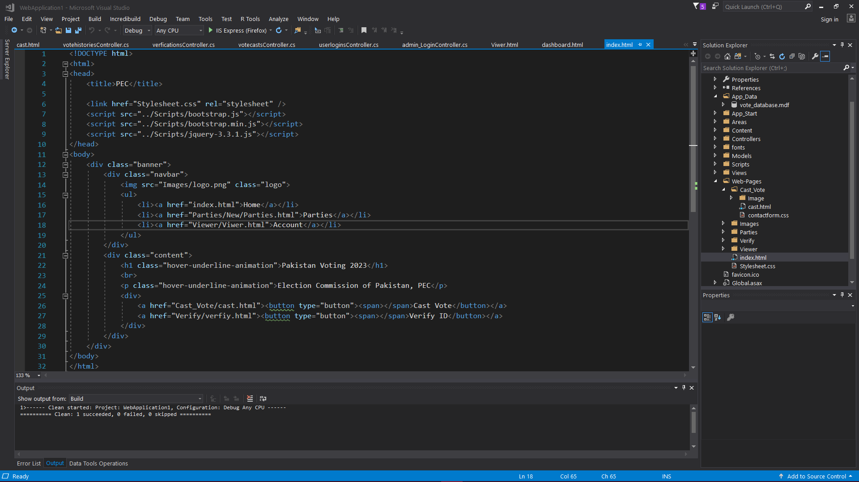

Figure 2: Index Page

## Cast Vote Page

<!DOCTYPE html>

<html lang="en">

<head>

<title>Cast Vote</title>

<meta charset="UTF-8">

<meta name="viewport" content="width=device-width, initial-scale=1.0">

<title>Document</title>

<script src="../../Scripts/bootstrap.js"></script>

<link href="https://stackpath.bootstrapcdn.com/font-awesome/4.7.0/css/font-awesome.min.css" rel="stylesheet"

integrity="sha384-wvfXpqpZZVQGK6TAh5PVlGOfQNHSoD2xbE+QkPxCAFlNEevoEH3Sl0sibVcOQVnN" crossorigin="anonymous">

</head>

<style>

body{

background-image: url("Image/cast_vote_background.jpg");

background-repeat: no-repeat;

background-position: center;

background-size: cover;

height: 100vh;

width: 100vh;

}

h2{

font-family: Helvetica ;

}

</style>

<body>

<div class="wrapper">

<h2> Vote Casting</h2>

<form action="#" method="POST">

<div class="input-group">

<div class="input-box">

<label>Party</label>

<input type="text" placeholder="Party" required class="name">

<i class="fa fa-user"></i>

</div>

<div class="input-box">

<label>Post</label>

<input type="text" placeholder="MPA " required class="name">

<i class="fa fa-user"></i>

</div>

</div>

<div class="input-group">

<div class="input-box">

<label>Post</label>

<input type="text" placeholder="MPA" required class="name">

<i class="fa fa-user"></i>

</div>

<div class="input-box">

<label>Email</label>

<input type="email" placeholder="Email" required class="name">

<i class="fa fa-envelope"></i>

</div>

</div>

<div class="button-group">

<div class="button-box">

<button type="submit"><i class="fa fa-paper-plane"></i> Cast Vote</button>

</div>

</div>

</form>

</div>

</body>

</html>

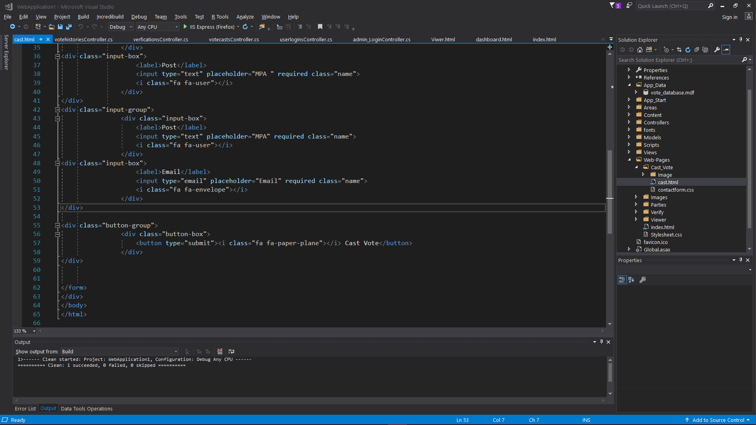

Figure 3: Cast Vote Page

## Parties Website

<html>

<head></head>

<title>Political Parties</title>

<link rel="stylesheet" href="styles.css" type="text/css">

<script src="../../../Scripts/bootstrap.js"></script>

<script src="../../../Scripts/jquery-3.3.1.js"></script>

<body>

<div class="banner">

<div class="Heading"></div>

<div class="header">

<h1 class="hover-underline-animation">Political Parties</h1>

</div>

<table>

<tr>

<th>Party Symbol </th>

<th>Party Name</th>

<th>Party History</th>

</tr>

<tr>

<td><img src="Images/1200px-Pakistan_Tehreek-e-Insaf_logo.svg.png" class="Image"></td>

<td>Pakistan Tehreek-e-Insaf اکستان تحريکِ انصاف</td>

<td>Pakistan Tehreek-e-Insaf was founded by Imran Khan on 25 April 1996 in Lahore. Founded initially as a sociopolitical movement, in June 1996 the first Central Executive Committee of Pakistan Tehreek-e-Insaf was formed under the leadership of Imran Khan, including Naeemul Haque, Ahsan Rasheed, Hafeez Khan, Mowahid Hussain, Mahmood Awan and Nausherwan Burki as founding members. PTI began to grow slowly but did not achieve immediate popularity. </td>

</tr>

<tr>

<div class="PPP">

<td><img src="Images/PPP.png" class="Image"></td>

<td>Pakistan People Parties پاکستان پیپلز پارٹی</td>

<td>The Pakistan Peoples Party (PPP) was launched at its founding convention held in Lahore on 30 November and 1 December 1967. At the same meeting, Zulfiqar Ali Bhutto was elected as its chairman. Among the expressed goals of the party were the establishment of an "egalitarian democracy" and the "application of socialistic ideas to realize economic and social justice". A more immediate task was the struggle against the dictatorship of General Ayub Khan, who was at the height of his power when the PPP was formed.</td>

</div>

</tr>

<div>

<tr>

<td><img src="Images/PML-N.png" class="Image"></td>

<td>Pakistan Muslim League Nawaz پاکستان مسلم لیگ (ن</td>

<td>The Pakistani Muslim League (Nawaz) (Urdu: پاکستان مسلم لیگ (ن), romanized: Pākistān Muslam Lig (Nūn) abbr. PML(N) or PML-N) is a centre-right, conservative political party in Pakistan. Alongside the Pakistan Tehreek-e-Insaf (PTI) and Pakistan Peoples Party (PPP), it is one of the three major political parties of the country. The party was founded by former Prime Minister Nawaz Sharif after the dissolution of Islamic Democratic Alliance in 1993. The party's platform is generally conservative, which involves supporting free markets, deregulation,lower taxes and private ownership. Although the party historically supported social conservatism, in recent years, the party’s political ideology and platform has become more liberal on social and cultural issues.

One of several continuing factions of the original Muslim League,the seeds of the party were sown following the 1985 Elections when the Prime Minister of Pakistan Muhammad Khan Junejo organised the supporters of President Zia-ul-Haq's dictatorship into a single party, known as the Pakistan Muslim League. After President Zia's death in 1988, under the leadership of Fida Mohammad Khan, a large faction split away from the Junejo-led Pakistan Muslim League, and formed a conservative alliance with various right-wing and Islamist political parties, called the Islamic Democratic Alliance. The alliance formed a government in 1990 under the leadership of Nawaz Sharif.

In 1993, the alliance dissolved and the party assumed its current shape, branding itself as the "Nawaz" faction of the Pakistan Muslim League, in contrast to the "Junejo" faction.After its foundation, the PML-N, along with the People's Party, dominated the two-party political system of Pakistan. However, after the 1999 coup, the party was eclipsed by its own splinter faction, the Musharraf - backed Pakistan Muslim League (Quaid), for almost a decade. PML-N regained popularity in the 2008 general elections, when it was elected as the principal opposition party. It returned to power following the elections of 2013, with Sharif elected as the Prime Minister for an unprecedented third term. The party however faced a major setback following the disqualification of Prime Minister Sharif in 2017. The situation was further made worse when Sharif and his daughter Maryam were sentenced to imprisonment on charges of corruption.

The party lost both the centre and the provincial government of its stonghold Punjab,[17] to PTI in 2018 elections. As of 2020, it is the main opposition party in the Parliament under the leadership of Sharif's younger brother Shehbaz. </td>

</tr>

</div>

<div>

<tr>

<td><img src="Images/Jamaat-e-Islami%20Pakistan.png" class="Image"></td>

<td>Jamaat-e-Islami Pakistan جمیعت علمائے اسلام </td>

<td>Jamaat-e-Islami's founder and leader until 1972, was Abul A'la Maududi, a widely read Islamist philosopher and political commentator, who wrote about the role of Islam in South Asia.[18] His thought was influenced by many factors including the Khilafat Movement; Mustafa Kemal Atatürk's ascension at the end of the Ottoman Caliphate; and the impact of Indian Nationalism, the Indian National Congress and Hinduism on Muslims in India. He supported what he called "Islamization from above", through an Islamic state in which sovereignty would be exercised in the name of Allah and Islamic law (sharia) would be implemented. Mawdudi believed politics was "an integral, inseparable part of the Islamic faith, and that the Islamic state that Muslim political action seeks to build" would not only be an act of piety but would also solve the many (seemingly non-religious) social and economic problems that Muslims faced.

Jamaat-e-Islami Headquarter in Lahore

Maududi opposed British rule but also opposed the Muslim nationalist movement (nationalism being un-Islamic) and their plan for a circumscribed "Muslim state". Maududi agitating instead for an "Islamic state" covering the whole of India[18]—this despite the fact Muslims made up only about one quarter of India's population.

Jamaat-e-Islami thus actively opposed the partition of India, with its leader Maulana Abul A'la Maududi arguing that concept violated the Islamic doctrine of the ummah. The Jamaat-e-Islami saw the partition as creating a temporal border that would divide Muslims from one another. </td>

</tr>

</div>

<div>

<tr>

<td><img src="Images/Awami%20National%20Party%20.png" class="Image"></td>

<td>Awami National Party عوامی نيشنل پارٹی</td>

<td>Khan Abdul Wali Khan's political career had been built on the tradition of intense Pashtun nationalism inherited from his father, Khan Abdul Ghaffar Khan (Bacha Khan). Although it was formed after the partition of India, most of its leaders had favoured a united India, and had opposed the partition of India and the creation of Pakistan.[6] Most of the leaders were Indian National Congress right hands before the partition of India. Both men were opposed to the creation of Pakistan, and after the creation of Pakistan in 1947, they were imprisoned. In 1956 Wali Khan joined the National Awami Party (NAP), led by a charismatic Bengali socialist, Abdul Hamid Khan Bhashani. In 1965 the NAP split into two factions, with Wali Khan becoming president of the pro-Moscow faction.[7] The party's members participated in 1970 parliamentary elections through the Pakistan Peoples Party's platform and the National Awami Party, forming a largest socialist alliance with Zulfikar Ali Bhutto in 1970. However, the alliance fell apart and its members joined the Pakistan National Alliance.

In 1972 the party was strong enough to form coalition provincial governments, with its partner the Jamiat Ulema-e-Islam (JUI) in Khyber Pakhtunkhwa and Balochistan. These governments were short lived. Wali Khan was again jailed, and his party was barred from politics when the Supreme Court upheld the finding of President Bhutto that the NAP was conspiring against the state of Pakistan. General Zia-ul-Haq subsequently withdrew the charges against the NAP. Wali Khan was released, joined the National Democratic Party, and ultimately formed the Awami National Party. In the meantime, Prime Minister Bhutto was imprisoned and executed in April 1979.

</td>

</tr>

</div>

</table>

</div>

</body>

</html>

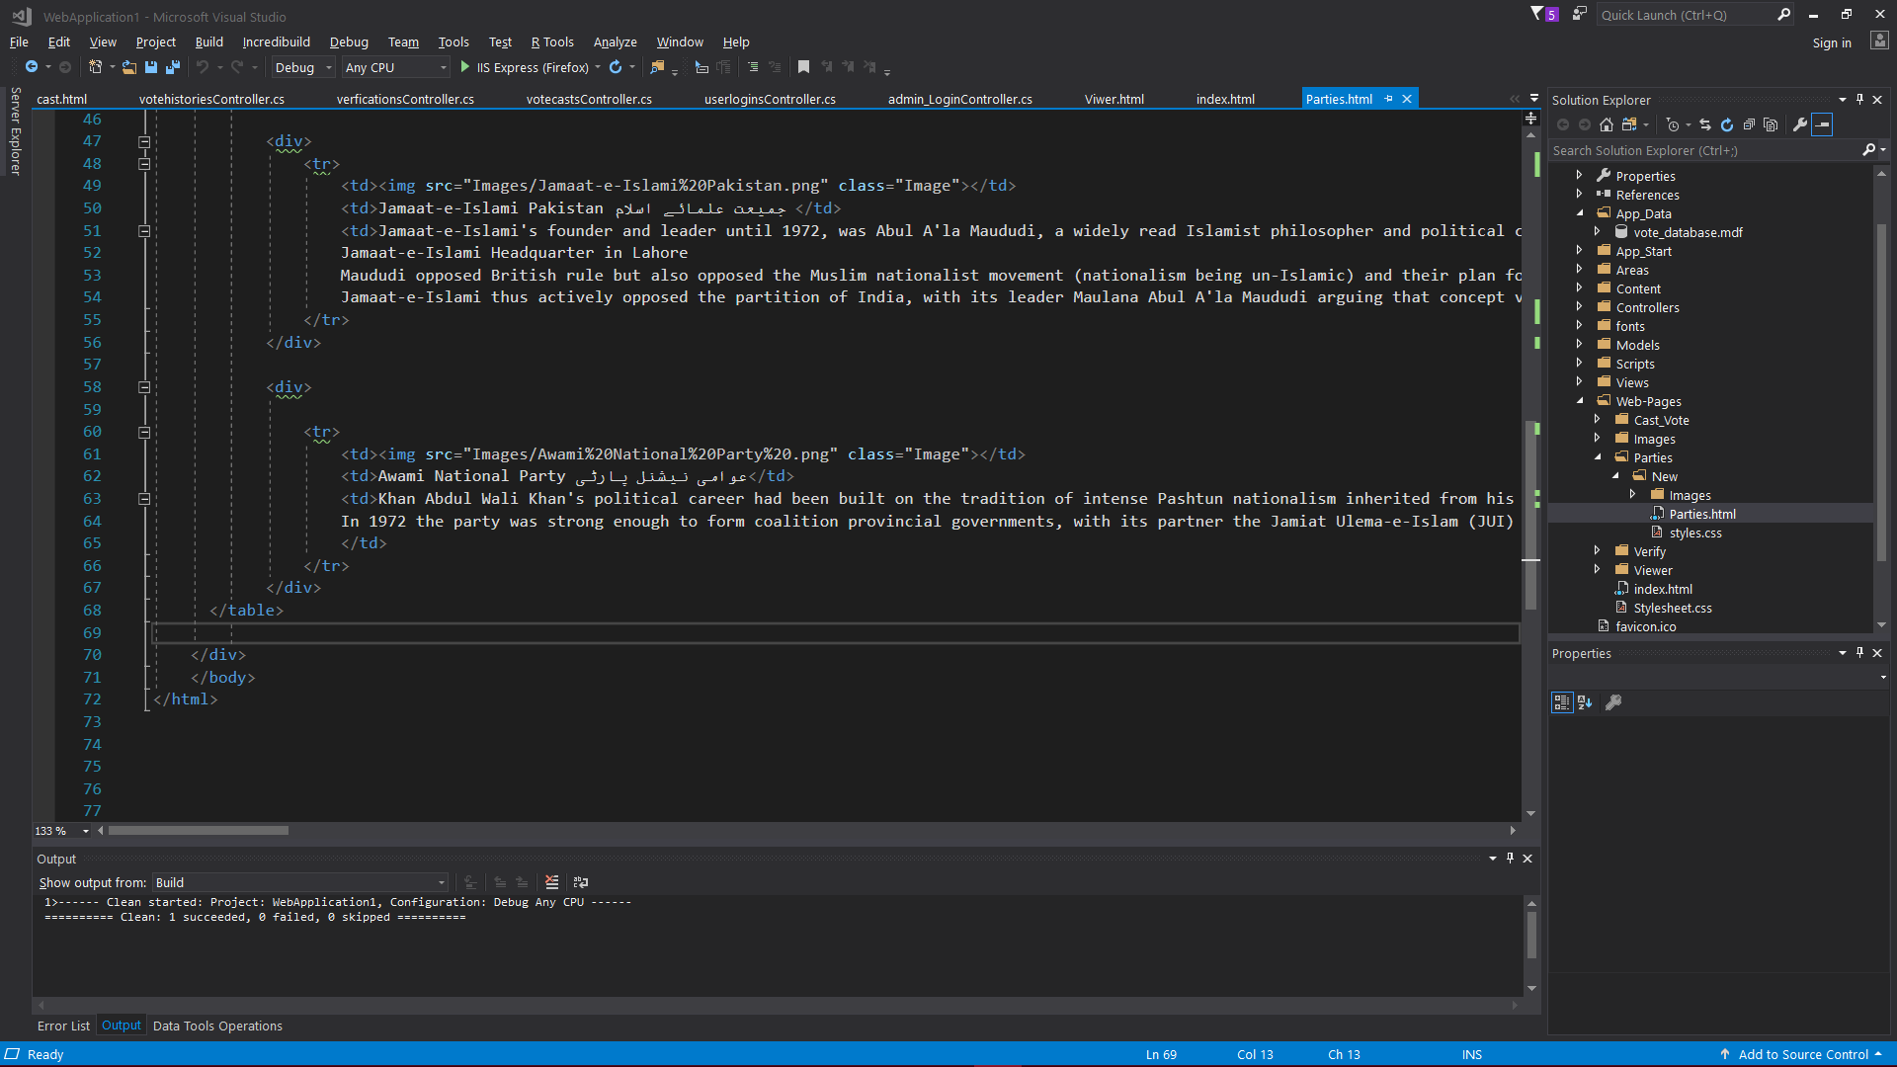

**Figure 4: Parties**

## Verify Page:

<!DOCTYPE html>

<html lang="en">

<head>

<title>Verfiy Account</title>

<meta charset="UTF-8">

<meta name="viewport" content="width=device-width, initial-scale=1.0">

<title>Document</title>

<script src="../../Scripts/bootstrap.js"></script>

<script src="../../Scripts/jquery-3.3.1.js"></script>

<!----- <link href="contactform.css" rel="stylesheet"> -->

<link href="https://stackpath.bootstrapcdn.com/font-awesome/4.7.0/css/font-awesome.min.css" rel="stylesheet"

integrity="sha384-wvfXpqpZZVQGK6TAh5PVlGOfQNHSoD2xbE+QkPxCAFlNEevoEH3Sl0sibVcOQVnN" crossorigin="anonymous">

</head>

<style>

body{

background-image: url("Image/background1.jpg");

background-repeat: no-repeat;

background-position: center;

background-size: cover;

height: 100vh;

width: 100vh;

}

h2{

font-family: Helvetica ;

}

</style>

<body>

<div class="wrapper">

<h2> Verification</h2>

<form action="#" method="POST">

<div class="input-group">

<div class="input-box">

<label>Name</label>

<input type="text" placeholder="Name" required class="name">

<i class="fa fa-user"></i>

</div>

<div class="input-box">

<label>CNIC</label>

<input type="text" placeholder="CNIC" required class="name">

<i class="fa fa-user"></i>

</div>

</div>

<div class="input-group">

<div class="input-box">

<label>Email</label>

<input type="email" placeholder="Email" required class="name">

<i class="fa fa-user"></i>

</div>

<div class="input-box">

<label>Phone Number</label>

<input type="tel" placeholder="Phone Number" required class="name">

<i class="fa fa-envelope"></i>

</div>

</div>

<div class="button-group">

<div class="button-box">

<button type="submit"><i class="fa fa-paper-plane"></i> Verify ID</button>

</div>

</div>

</form>

</div>

</body>

</html>

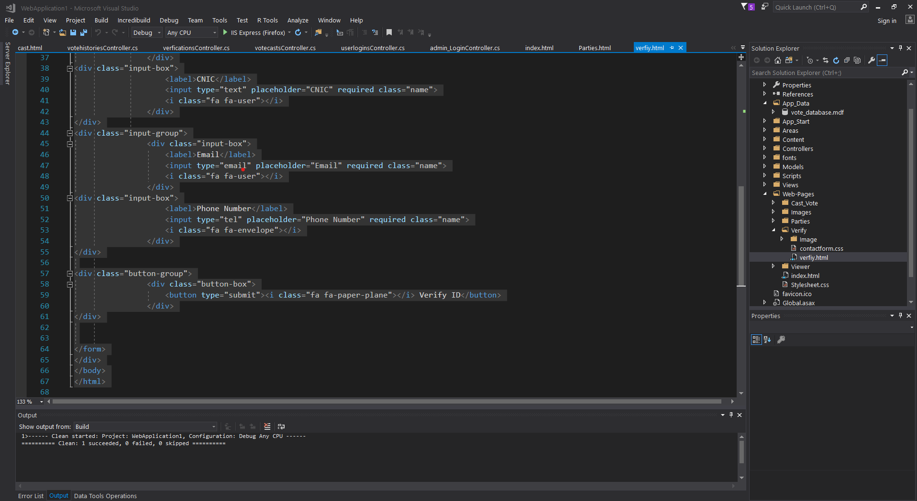

Figure : verfiy Page

## Admin Login

<!doctype html>

<html lang="en">

<head>

<title>Admin Login</title>

<meta charset="utf-8">

<meta name="viewport" content="width=device-width, initial-scale=1, shrink-to-fit=no">

<link href="https://fonts.googleapis.com/css?family=Lato:300,400,700&display=swap" rel="stylesheet">

<script src="../../../Scripts/bootstrap.js"></script>

<script src="../../../Scripts/jquery-3.3.1.js"></script>

<link rel="stylesheet" href="https://stackpath.bootstrapcdn.com/font-awesome/4.7.0/css/font-awesome.min.css">

<link rel="stylesheet" href="css/style.css" type="text/css">

</head>

<body class="img js-fullheight" style="background-image: url(images/bg.jpg);">

<section class="ftco-section">

<div class="container">

<div class="row justify-content-center">

<div class="col-md-6 text-center mb-5">

<h2 class="heading-section">Admin Login</h2>

</div>

</div>

<div class="row justify-content-center">

<div class="col-md-6 col-lg-4">

<div class="login-wrap p-0">

<h3 class="mb-4 text-center">Have an account?</h3>

<form action="#" class="signin-form">

<div class="form-group">

<input type="text" class="form-control" placeholder="Username" required>

</div>

<div class="form-group">

<input id="password-field" type="password" class="form-control" placeholder="Password" required>

<span toggle="#password-field" class="fa fa-fw fa-eye field-icon toggle-password"></span>

</div>

<div class="form-group">

<a href="dashboard/AdminDashBoard.html">

<button type="button" class="form-control btn btn-primary submit px-3">Sign In</button>

</a>

</div>

</form>

</div>

</div>

</div>

</div>

</section>

<script src="js/jquery.min.js"></script>

<script src="js/popper.js"></script>

<script src="js/bootstrap.min.js"></script>

<script src="js/main.js"></script>

</body>

</html>

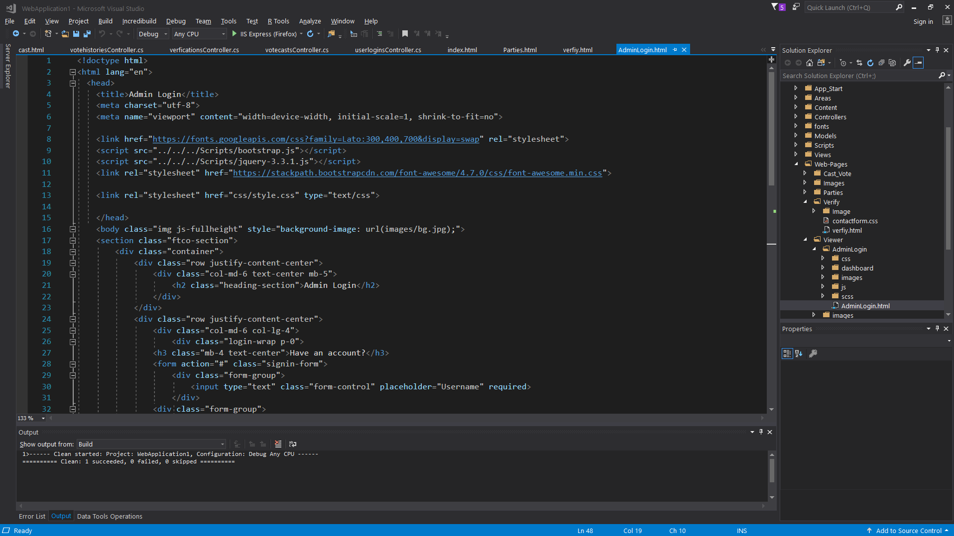

**Figure 6: Admin Login Page**

## Admin Dashboard:

<!DOCTYPE html>

<html lang="en">

<head>

<meta charset="UTF-8" />

<meta name="viewport" content="width=device-width, initial-scale=1.0" />

<link rel="stylesheet"

href="https://stackpath.bootstrapcdn.com/font-awesome/4.7.0/css/font-awesome.min.css"

integrity="sha384-wvfXpqpZZVQGK6TAh5PVlGOfQNHSoD2xbE+QkPxCAFlNEevoEH3Sl0sibVcOQVnN"

crossorigin="anonymous" />

<script src="../../../../Scripts/bootstrap.js"></script>

<script src="../../../../Scripts/jquery-3.3.1.js"></script>

<link rel="stylesheet" href="stylesAD.css" type="text/css" />

<script src="../../../../Scripts/bootstrap.js"></script>

<script src="../../../../Scripts/jquery-3.3.1.js"></script>

<script src="../js/bootstrap.min.js"></script>

<script src="../js/jquery.min.js"></script>

<script src="../js/main.js"></script>

<script src="../js/popper.js"></script>

<title>Admin Dashboard</title>

</head>

<body id="body">

<div class="container">

<nav class="navbar">

<div class="nav_icon" onclick="toggleSidebar()">

<i class="fa fa-bars" aria-hidden="true"></i>

</div>

<div class="navbar__left">

<a class="active_link" href="#">Admin</a>

</div>

<div class="navbar__right">

<a href="#">

<i class="fa fa-search" aria-hidden="true"></i>

</a>

<a href="#">

<i class="fa fa-clock-o" aria-hidden="true"></i>

</a>

<a href="#">

<img width="30" src="assets/logo.png" alt="" />

<!-- <i class="fa fa-user-circle-o" aria-hidden="true"></i> -->

</a>

</div>

</nav>

<main>

<div class="main__container">

<!-- MAIN TITLE STARTS HERE -->

<div class="main__title">

<img src="assets/logo.png" alt="" />

<div class="main__greeting">

<h1>Hello Admin</h1>

<p>Welcome to your admin dashboard</p>

</div>

</div>

<!-- MAIN TITLE ENDS HERE -->

<!-- MAIN CARDS STARTS HERE -->

<div class="main__cards">

<div class="card">

<i

class="fa fa-user-o fa-2x text-lightblue"

aria-hidden="true"

></i>

<div class="card_inner">

<p class="text-primary-p">Total votes casted</p>

<span class="font-bold text-title">578</span>

</div>

</div>

<div class="card">

<i class="fa fa-calendar fa-2x text-red" aria-hidden="true"></i>

<div class="card_inner">

<p class="text-primary-p">Yearly Voting Schedule</p>

<span class="font-bold text-title">2467</span>

</div>

</div>

<div class="card">

<i

class="fa fa-video-camera fa-2x text-yellow"

aria-hidden="true"

></i>

<div class="card_inner">

<p class="text-primary-p">Live coverage</p>

<span class="font-bold text-title">340</span>

</div>

</div>

<div class="card">

<i

class="fa fa-thumbs-up fa-2x text-green"

aria-hidden="true"

></i>

<div class="card_inner">

<p class="text-primary-p">Postive voter review</p>

<span class="font-bold text-title">645</span>

</div>

</div>

</div>

<!-- MAIN CARDS ENDS HERE -->

<!-- CHARTS STARTS HERE -->

<div class="charts">

<div class="charts__left">

<div class="charts__left__title">

<div>

<h1>Daily Reports</h1>

<p>Pakistan</p>

</div>

</div>

<div id="apex1"></div>

</div>

<div class="charts__right">

<div class="charts__right__title">

<div>

<h1>Election Status</h1>

<p>Pakistan</p>

</div>

</div>

<div class="charts__right__cards">

<div class="card1">

<h1>2018</h1>

<p>115,748,753</p>

</div>

<div class="card2">

<h1>2009</h1>

<p>14,794,188</p>

</div>

<div class="card3">

<h1>2004</h1>

<p>16903702</p>

</div>

<div class="card4">

<h1>2000</h1>

<p>14587993</p>

</div>

</div>

</div>

</div>

<!-- CHARTS ENDS HERE -->

</div>

</main>

<div id="sidebar">

<div class="sidebar__title">

<div class="sidebar__img">

<img src="assets/logo.png" alt="logo" />

<h1>&nbsp PEC </h1>

</div>

<i

onclick="closeSidebar()"

class="fa fa-times"

id="sidebarIcon"

aria-hidden="true"

></i>

</div>

<div class="sidebar__menu">

<div class="sidebar__link active_menu_link">

<i class="fa fa-home"></i>

<a href="#">Dashboard</a>

</div>

<h2>MNG</h2>

<div class="sidebar__link">

<i class="fa fa-user-secret" aria-hidden="true"></i>

<a href="#">Admin Management</a>

</div>

<div class="sidebar__link">

<i class="fa fa-building-o"></i>

<a href="#">Provinces</a>

</div>

<div class="sidebar__link">

<i class="fa fa-wrench"></i>

<a href="#">Casted Vote</a>

</div>

<div class="sidebar__link">

<i class="fa fa-archive"></i>

<a href="#">Start Voting</a>

</div>

<div class="sidebar__link">

<i class="fa fa-handshake-o"></i>

<a href="#">End Voting</a>

</div>

<h2>LEAVE</h2>

<div class="sidebar__link">

<i class="fa fa-question"></i>

<a href="#">Requests</a>

</div>

<div class="sidebar__link">

<i class="fa fa-sign-out"></i>

<a href="#">Issues</a>

</div>

<h2>Maintanance</h2>

<div class="sidebar__link">

<i class="fa fa-money"></i>

<a href="#">Maintanance</a>

</div>

<div class="sidebar__link">

<i class="fa fa-briefcase"></i>

<a href="#">Contacts</a>

</div>

<div class="sidebar__logout">

<i class="fa fa-power-off"></i>

<a href="AdminLogin.html">Log out</a>

</div>

</div>

</div>

</div>

<script src="https://cdn.jsdelivr.net/npm/apexcharts"></script>

<script src="script.js"></script>

</body>

</html>

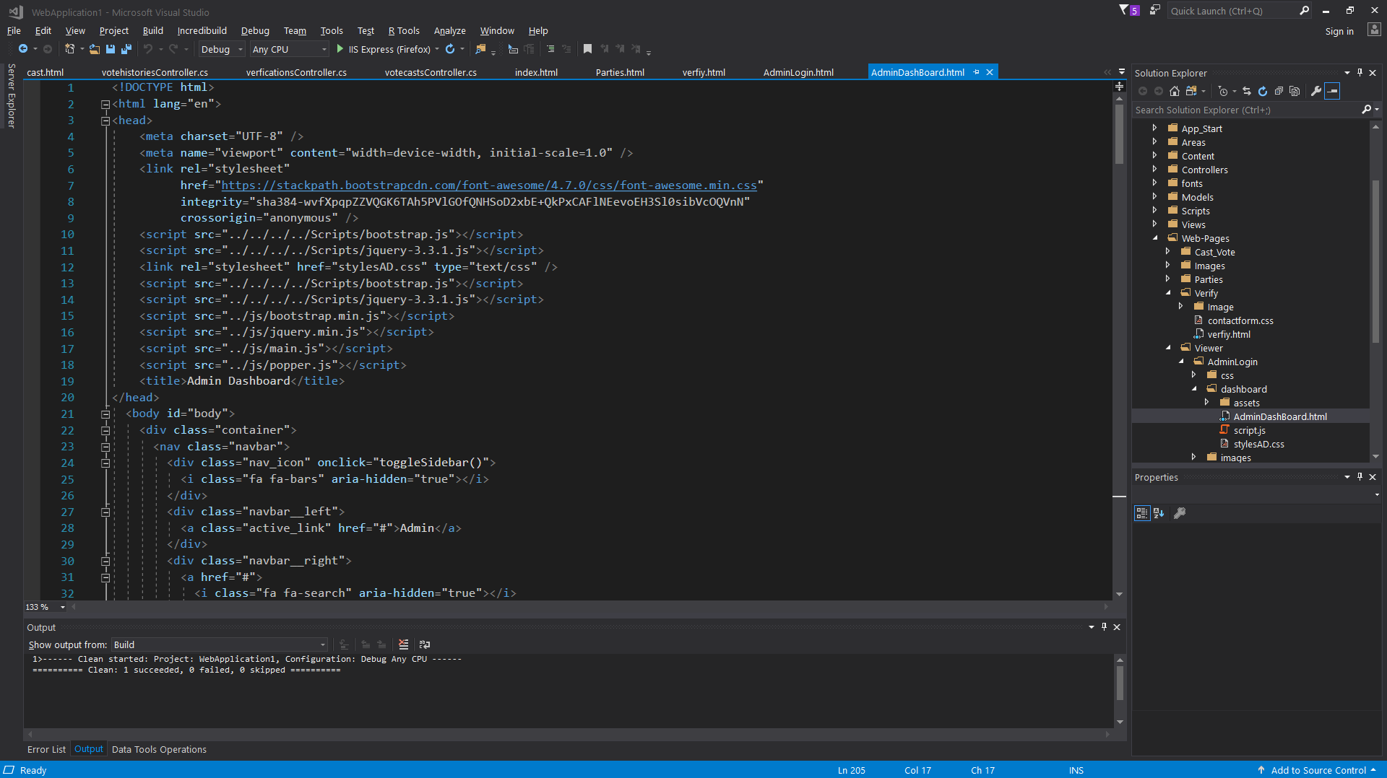

**Figure 7: admin Dashbard**

## User Login

<html>

<head>

<meta charset="utf-8">

<title>Login and Registtation Form</title>

<link rel="stylesheet" href="styles.css">

</head>

<body>

<div class="hero">

<div class="form-box">

<div class="button-box">

<div id="btn"></div>

<button type="button" class="toggle-btn" onclick="login()">Log In</button>

<button type="button" class="toggle-btn" onclick="register()">Register</button>

</div>

<div class="social-icons">

<img src="fb.png">

<img src="tw.png">

<img src="gp.png">

</div>

<form action="" method="post" id="login" class="input-group">

<input type="text" class="input-field" placeholder="User Id" name="username" required>

<input type="text" class="input-field" placeholder="Enter Password" name="password" required>

<br>

<input type="checkbox" class="check-box"><span>Remember Password</span>

<a href="../dashboard.html">

<button type="button" class="submit-btn" >Log in</button>

</a>

</form>

<form id="register" class="input-group">

<input type="text" class="input-field" placeholder="User Id" required>

<input type="email" class="input-field" placeholder="Email Id" required>

<input type="text" class="input-field" placeholder="Enter Password" required>

<br>

<input type="checkbox" class="check-box"><span>I agree to the Terms and Conditions </span>

<button type="submit" class="submit-btn">Register</button>

</form>

</div>

</div>

<script>

var x = document.getElementById("login");

var y = document.getElementById("register");

var z = document.getElementById("btn");

function register(){

x.style.left="-400px";

y.style.left="50px";

z.style.left="110px";

}

function login(){

x.style.left="50px";

y.style.left="450px";

z.style.left="0px";

}

</script>

</body>

</html>

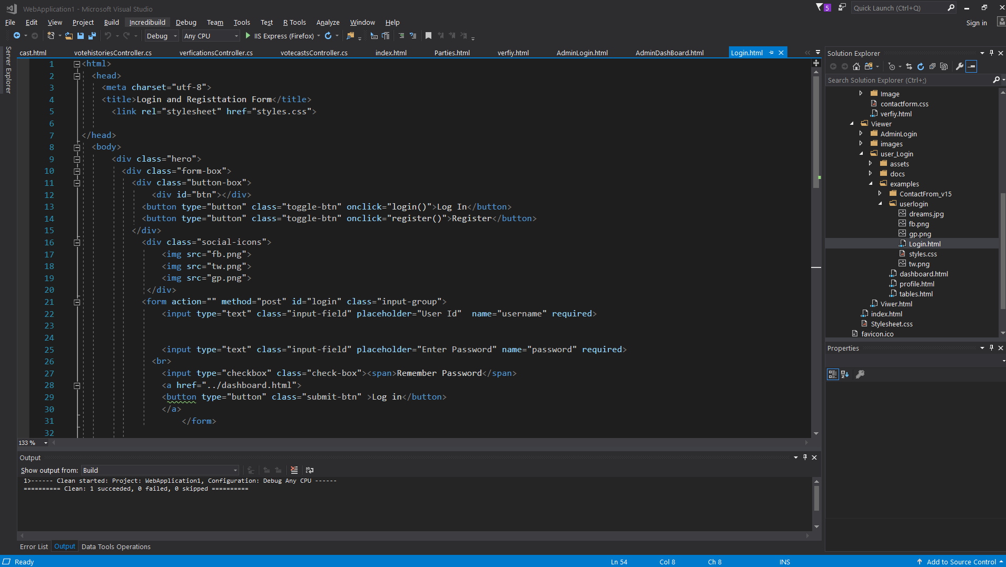

**Figure 8: user Login page**

## User Dashboard

<!DOCTYPE html>

<html>

<head>

<meta charset="utf-8">

<meta name="viewport" content="width=device-width, initial-scale=1, shrink-to-fit=no">

<meta name="description" content="Start your development with a Dashboard for Bootstrap 4.">

<meta name="author" content="Creative Tim">

<title>User Dashboard</title>

<!-- Favicon -->

<link rel="icon" href="../assets/img/brand/favicon.png" type="image/png">

<!-- Fonts -->

<link rel="stylesheet" href="https://fonts.googleapis.com/css?family=Open+Sans:300,400,600,700">

<!-- Icons -->

<link rel="stylesheet" href="../assets/vendor/nucleo/css/nucleo.css" type="text/css">

<link rel="stylesheet" href="../assets/vendor/@fortawesome/fontawesome-free/css/all.min.css" type="text/css">

<!-- Page plugins -->

<!-- Argon CSS -->

<link rel="stylesheet" href="../assets/css/argon.css?v=1.2.0" type="text/css">

<script src="../../../../Scripts/bootstrap.js"></script>

<script src="../../../../Scripts/jquery-3.3.1.js"></script>

</head>

<body>

<!-- Sidenav -->

<nav class="sidenav navbar navbar-vertical fixed-left navbar-expand-xs navbar-light bg-white" id="sidenav-main">

<div class="scrollbar-inner">

<!-- Brand -->

<div class="sidenav-header align-items-center">

<a class="navbar-brand" href="javascript:void(0)">

<img src="../assets/img/brand/blue.png" class="navbar-brand-img" alt="...">

</a>

</div>

<div class="navbar-inner">

<!-- Collapse -->

<div class="collapse navbar-collapse" id="sidenav-collapse-main">

<!-- Nav items -->

<ul class="navbar-nav">

<li class="nav-item">

<a class="nav-link active" href="dashboard.html">

<i class="ni ni-tv-2 text-primary"></i>

<span class="nav-link-text">Dashboard</span>

</a>

</li>

<li class="nav-item">

<a class="nav-link" href="profile.html">

<i class="ni ni-single-02 text-yellow"></i>

<span class="nav-link-text">Profile</span>

</a>

</li>

<li class="nav-item">

<a class="nav-link" href="tables.html">

<i class="ni ni-bullet-list-67 text-default"></i>

<span class="nav-link-text">Tables</span>

</a>

</li>

</ul>

</div>

</div>

</div>

</nav>

<!-- Main content -->

<div class="main-content" id="panel">

<!-- Topnav -->

<nav class="navbar navbar-top navbar-expand navbar-dark bg-primary border-bottom">

<div class="container-fluid">

<div class="collapse navbar-collapse" id="navbarSupportedContent">

<!-- Search form -->

<form class="navbar-search navbar-search-light form-inline mr-sm-3" id="navbar-search-main">

<div class="form-group mb-0">

<div class="input-group input-group-alternative input-group-merge">

<div class="input-group-prepend">

<span class="input-group-text"><i class="fas fa-search"></i></span>

</div>

<input class="form-control" placeholder="Search" type="text">

</div>

</div>

<button type="button" class="close" data-action="search-close" data-target="#navbar-search-main" aria-label="Close">

<span aria-hidden="true">×</span>

</button>

</form>

<!-- Navbar links -->

<ul class="navbar-nav align-items-center ml-md-auto ">

<li class="nav-item d-xl-none">

<!-- Sidenav toggler -->

<div class="pr-3 sidenav-toggler sidenav-toggler-dark" data-action="sidenav-pin" data-target="#sidenav-main">

<div class="sidenav-toggler-inner">

<i class="sidenav-toggler-line"></i>

<i class="sidenav-toggler-line"></i>

<i class="sidenav-toggler-line"></i>

</div>

</div>

</li>

<li class="nav-item d-sm-none">

<a class="nav-link" href="#" data-action="search-show" data-target="#navbar-search-main">

<i class="ni ni-zoom-split-in"></i>

</a>

</li>

<li class="nav-item dropdown">

<a class="nav-link" href="#" role="button" data-toggle="dropdown" aria-haspopup="true" aria-expanded="false">

<i class="ni ni-bell-55"></i>

</a>

<div class="dropdown-menu dropdown-menu-xl dropdown-menu-right py-0 overflow-hidden">

<!-- Dropdown header -->

<div class="px-3 py-3">

<h6 class="text-sm text-muted m-0">You have <strong class="text-primary">13</strong> notifications.</h6>

</div>

<!-- List group -->

<div class="list-group list-group-flush">

<a href="#!" class="list-group-item list-group-item-action">

<div class="row align-items-center">

<div class="col-auto">

<!-- Avatar -->

<img alt="Image placeholder" src="../assets/img/theme/team-1.jpg" class="avatar rounded-circle">

</div>

<div class="col ml--2">

<div class="d-flex justify-content-between align-items-center">

<div>

<h4 class="mb-0 text-sm">GOP</h4>

</div>

<div class="text-right text-muted">

<small></small>

</div>

</div>

<p class="text-sm mb-0">Votting Start at 13th April</p>

</div>

</div>

</a>

<a href="#!" class="list-group-item list-group-item-action">

<div class="row align-items-center">

<div class="col-auto">

<!-- Avatar -->

<img alt="Image placeholder" src="../assets/img/theme/team-2.jpg" class="avatar rounded-circle">

</div>

<div class="col ml--2">

<div class="d-flex justify-content-between align-items-center">

<div>

<h4 class="mb-0 text-sm">PEC</h4>

</div>

<div class="text-right text-muted">

<small>3 hrs ago</small>

</div>

</div>

<p class="text-sm mb-0">The results are here.</p>

</div>

</div>

</a>

<a href="#!" class="list-group-item list-group-item-action">

<div class="row align-items-center">

<div class="col-auto">

<!-- Avatar -->

<img alt="Image placeholder" src="../assets/img/theme/team-3.jpg" class="avatar rounded-circle">

</div>

<div class="col ml--2">

<div class="d-flex justify-content-between align-items-center">

<div>

<h4 class="mb-0 text-sm">PEC</h4>

</div>

<div class="text-right text-muted">

<small>5 hrs ago</small>

</div>

</div>

<p class="text-sm mb-0">Your posts have been liked a lot.</p>

</div>

</div>

</a>

<a href="#!" class="list-group-item list-group-item-action">

<div class="row align-items-center">

<div class="col-auto">

<!-- Avatar -->

<img alt="Image placeholder" src="../assets/img/theme/team-4.jpg" class="avatar rounded-circle">

</div>

<div class="col ml--2">

<div class="d-flex justify-content-between align-items-center">

<div>

<h4 class="mb-0 text-sm">GOP</h4>

</div>

<div class="text-right text-muted">

<small>2 hrs ago</small>

</div>

</div>

<p class="text-sm mb-0">There was a problem so election will be held again.</p>

</div>

</div>

</a>

<a href="#!" class="list-group-item list-group-item-action">

<div class="row align-items-center">

<div class="col-auto">

<!-- Avatar -->

<img alt="Image placeholder" src="../assets/img/theme/team-5.jpg" class="avatar rounded-circle">

</div>

<div class="col ml--2">

<div class="d-flex justify-content-between align-items-center">

<div>

<h4 class="mb-0 text-sm">GOP</h4>

</div>

<div class="text-right text-muted">

<small>3 hrs ago</small>

</div>

</div>

<p class="text-sm mb-0">Service will be down for an hour.</p>

</div>

</div>

</a>

</div>

<!-- View all -->

<a href="#!" class="dropdown-item text-center text-primary font-weight-bold py-3">View all</a>

</div>

</li>

</ul>

<ul class="navbar-nav align-items-center ml-auto ml-md-0 ">

<li class="nav-item dropdown">

<a class="nav-link pr-0" href="#" role="button" data-toggle="dropdown" aria-haspopup="true" aria-expanded="false">

<div class="media align-items-center">

<span class="avatar avatar-sm rounded-circle">

<img alt="Image placeholder" src="../assets/img/theme/team-4.jpg">

</span>

<div class="media-body ml-2 d-none d-lg-block">

<span class="mb-0 text-sm font-weight-bold">User</span>

</div>

</div>

</a>

<div class="dropdown-menu dropdown-menu-right ">

<div class="dropdown-header noti-title">

<h6 class="text-overflow m-0">Welcome!</h6>

</div>

<a href="profile.html" class="dropdown-item">

<i class="ni ni-single-02"></i>

<span>My profile</span>

</a>

<a href="#!" class="dropdown-item">

<i class="ni ni-settings-gear-65"></i>

<span>Settings</span>

</a>

<a href="#!" class="dropdown-item">

<i class="ni ni-calendar-grid-58"></i>

<span>Activity</span>

</a>

<div class="dropdown-divider"></div>

<a href="userlogin/Login.html" class="dropdown-item">

<i class="ni ni-user-run"></i>

<span>Logout</span>

</a>

</div>

</li>

</ul>

</div>

</div>

</nav>

<!-- Header -->

<!-- Header -->

<div class="header bg-primary pb-6">

<div class="container-fluid">

<div class="header-body">

<div class="row align-items-center py-4">

<div class="col-lg-6 col-7">

<h6 class="h2 text-white d-inline-block mb-0">Default</h6>

<nav aria-label="breadcrumb" class="d-none d-md-inline-block ml-md-4">

<ol class="breadcrumb breadcrumb-links breadcrumb-dark">

<li class="breadcrumb-item"><a href="#"><i class="fas fa-home"></i></a></li>

<li class="breadcrumb-item"><a href="#">Dashboards</a></li>

<li class="breadcrumb-item active" aria-current="page">Default</li>

</ol>

</nav>

</div>

<div class="col-lg-6 col-5 text-right">

<a href="#" class="btn btn-sm btn-neutral">New</a>

<a href="#" class="btn btn-sm btn-neutral">Filters</a>

</div>

</div>

<!-- Card stats -->

<div class="row">

<div class="col-xl-3 col-md-6">

<div class="card card-stats">

<!-- Card body -->

<div class="card-body">

<div class="row">

<div class="col">

<h5 class="card-title text-uppercase text-muted mb-0">Total Votes</h5>

<span class="h2 font-weight-bold mb-0">350,897,0000</span>

</div>

<div class="col-auto">

<div class="icon icon-shape bg-gradient-red text-white rounded-circle shadow">

<i class="ni ni-active-40"></i>

</div>

</div>

</div>

<p class="mt-3 mb-0 text-sm">

<span class="text-success mr-2"><i class="fa fa-arrow-up"></i> 15.48%</span>

<span class="text-nowrap">Since last month</span>

</p>

</div>

</div>

</div>

<div class="col-xl-3 col-md-6">

<div class="card card-stats">

<!-- Card body -->

<div class="card-body">

<div class="row">

<div class="col">

<h5 class="card-title text-uppercase text-muted mb-0">New User Votes</h5>

<span class="h2 font-weight-bold mb-0">2,356</span>

</div>

<div class="col-auto">

<div class="icon icon-shape bg-gradient-orange text-white rounded-circle shadow">

<i class="ni ni-chart-pie-35"></i>

</div>

</div>

</div>

<p class="mt-3 mb-0 text-sm">

<span class="text-success mr-2"><i class="fa fa-arrow-up"></i> 3.48%</span>

<span class="text-nowrap">Since last month</span>

</p>

</div>

</div>

</div>

<div class="col-xl-3 col-md-6">

<div class="card card-stats">

<!-- Card body -->

<div class="card-body">

<div class="row">

<div class="col">

<h5 class="card-title text-uppercase text-muted mb-0">Total Number of Votes in.</h5>

<span class="h2 font-weight-bold mb-0">924</span>

</div>

<div class="col-auto">

<div class="icon icon-shape bg-gradient-green text-white rounded-circle shadow">

<i class="ni ni-money-coins"></i>

</div>

</div>

</div>

<p class="mt-3 mb-0 text-sm">

<span class="text-success mr-2"><i class="fa fa-arrow-up"></i> 3.48%</span>

<span class="text-nowrap">Since last day</span>

</p>

</div>

</div>

</div>

<div class="col-xl-3 col-md-6">

<div class="card card-stats">

<!-- Card body -->

<div class="card-body">

<div class="row">

<div class="col">

<h5 class="card-title text-uppercase text-muted mb-0">Performance of Parties</h5>

<span class="h2 font-weight-bold mb-0">49,65%</span>

</div>

<div class="col-auto">

<div class="icon icon-shape bg-gradient-info text-white rounded-circle shadow">

<i class="ni ni-chart-bar-32"></i>

</div>

</div>

</div>

<p class="mt-3 mb-0 text-sm">

<span class="text-success mr-2"><i class="fa fa-arrow-up"></i> 3.48%</span>

<span class="text-nowrap">Since last month</span>

</p>

</div>

</div>

</div>

</div>

</div>

</div>

</div>

<!-- Page content -->

<div class="container-fluid mt--6">

<div class="row">

<div class="col-xl-8">

<div class="card bg-default">

<div class="card-header bg-transparent">

<div class="row align-items-center">

<div class="col">

<h6 class="text-light text-uppercase ls-1 mb-1">Overview</h6>

<h5 class="h3 text-white mb-0">Votes</h5>

</div>

<div class="col">

<ul class="nav nav-pills justify-content-end">

<li class="nav-item mr-2 mr-md-0" data-toggle="chart" data-target="#chart-sales-dark" data-update='{"data":{"datasets":[{"data":[0, 20, 10, 30, 15, 40, 20, 60, 60]}]}}' data-prefix="" data-suffix="k">

<a href="#" class="nav-link py-2 px-3 active" data-toggle="tab">

<span class="d-none d-md-block">Month</span>

<span class="d-md-none">M</span>

</a>

</li>

<li class="nav-item" data-toggle="chart" data-target="#chart-sales-dark" data-update='{"data":{"datasets":[{"data":[0, 20, 5, 25, 10, 30, 15, 40, 40]}]}}' data-prefix="" data-suffix="k">

<a href="#" class="nav-link py-2 px-3" data-toggle="tab">

<span class="d-none d-md-block">Week</span>

<span class="d-md-none">W</span>

</a>

</li>

</ul>

</div>

</div>

</div>

<div class="card-body">

<!-- Chart -->

<div class="chart">

<!-- Chart wrapper -->

<canvas id="chart-sales-dark" class="chart-canvas"></canvas>

</div>

</div>

</div>

</div>

<div class="col-xl-4">

<div class="card">

<div class="card-header bg-transparent">

<div class="row align-items-center">

<div class="col">

<h6 class="text-uppercase text-muted ls-1 mb-1">Performance</h6>

<h5 class="h3 mb-0">Total Votes</h5>

</div>

</div>

</div>

<div class="card-body">

<!-- Chart -->

<div class="chart">

<canvas id="chart-bars" class="chart-canvas"></canvas>

</div>

</div>

</div>

</div>

</div>

<div class="row">

<div class="col-xl-8">

<div class="card">

<div class="card-header border-0">

<div class="row align-items-center">

<div class="col">

<h3 class="mb-0">New Sites traffic</h3>

</div>

</div>

</div>

<div class="table-responsive">

<!-- Projects table -->

<table class="table align-items-center table-flush">

<thead class="thead-light">

<tr>

<th scope="col">Page name</th>

<th scope="col">Visitors</th>

<th scope="col">Unique users</th>

<th scope="col">Bounce rate</th>

</tr>

</thead>

<tbody>

<tr>

<th scope="row">

Ary News <br>

<h6>https://arynews.tv</h6>

</th>

<td>

4,569

</td>

<td>

340

</td>

<td>

<i class="fas fa-arrow-up text-success mr-3"></i> 46,53%

</td>

</tr>

<tr>

<th scope="row">

Geo News

<br>

<h6>https://www.geo.tv/</h6>

</th>

<td>

3,985

</td>

<td>

319

</td>

<td>

<i class="fas fa-arrow-down text-warning mr-3"></i> 46,53%

</td>

</tr>

<tr>

<th scope="row">

24 News

<br>

<h6>https://www.geo.tv/</h6>

</th>

<td>

3,513

</td>

<td>

294

</td>

<td>

<i class="fas fa-arrow-down text-warning mr-3"></i> 36,49%

</td>

</tr>

<tr>

<th scope="row">

92 News

<br>

<h6>https://www.92news.tv/</h6>

</th>

<td>

2,050

</td>

<td>

147

</td>

<td>

<i class="fas fa-arrow-up text-success mr-3"></i> 50,87%

</td>

</tr>

<tr>

<th scope="row">

Bol News

<br>

<h6>https://www.bol.tv/</h6>

</th>

<td>

1,795

</td>

<td>

190

</td>

<td>

<i class="fas fa-arrow-down text-danger mr-3"></i> 46,53%

</td>

</tr>

</tbody>

</table>

</div>

</div>

</div>

<div class="col-xl-4">

<div class="card">

<div class="card-header border-0">

<div class="row align-items-center">

<div class="col">

<h3 class="mb-0">Social traffic</h3>

</div>

</div>

</div>

<div class="table-responsive">

<!-- Projects table -->

<table class="table align-items-center table-flush">

<thead class="thead-light">

<tr>

<th scope="col">Referral</th>

<th scope="col">Visitors</th>

<th scope="col"></th>

</tr>

</thead>

<tbody>

<tr>

<th scope="row">

Facebook

</th>

<td>

1,480

</td>

<td>

<div class="d-flex align-items-center">

<span class="mr-2">60%</span>

<div>

<div class="progress">

<div class="progress-bar bg-gradient-danger" role="progressbar" aria-valuenow="60" aria-valuemin="0" aria-valuemax="100" style="width: 60%;"></div>

</div>

</div>

</div>

</td>

</tr>

<tr>

<th scope="row">

Facebook

</th>

<td>

5,480

</td>

<td>

<div class="d-flex align-items-center">

<span class="mr-2">70%</span>

<div>

<div class="progress">

<div class="progress-bar bg-gradient-success" role="progressbar" aria-valuenow="70" aria-valuemin="0" aria-valuemax="100" style="width: 70%;"></div>

</div>

</div>

</div>

</td>

</tr>

<tr>

<th scope="row">

Google

</th>

<td>

4,807

</td>

<td>

<div class="d-flex align-items-center">

<span class="mr-2">80%</span>

<div>

<div class="progress">

<div class="progress-bar bg-gradient-primary" role="progressbar" aria-valuenow="80" aria-valuemin="0" aria-valuemax="100" style="width: 80%;"></div>

</div>

</div>

</div>

</td>

</tr>

<tr>

<th scope="row">

Instagram

</th>

<td>

3,678

</td>

<td>

<div class="d-flex align-items-center">

<span class="mr-2">75%</span>

<div>

<div class="progress">

<div class="progress-bar bg-gradient-info" role="progressbar" aria-valuenow="75" aria-valuemin="0" aria-valuemax="100" style="width: 75%;"></div>

</div>

</div>

</div>

</td>

</tr>

<tr>

<th scope="row">

twitter

</th>

<td>

2,645

</td>

<td>

<div class="d-flex align-items-center">

<span class="mr-2">30%</span>

<div>

<div class="progress">

<div class="progress-bar bg-gradient-warning" role="progressbar" aria-valuenow="30" aria-valuemin="0" aria-valuemax="100" style="width: 30%;"></div>

</div>

</div>

</div>

</td>

</tr>

</tbody>

</table>

</div>

</div>

</div>

</div>

<!-- Footer -->

<footer class="footer pt-0">

<div class="row align-items-center justify-content-lg-between">

<div class="col-lg-6">

<div class="copyright text-center text-lg-left text-muted">

&copy; 2020 <a href="" class="font-weight-bold ml-1" target="_blank">Abdul Rafay & Haseeb Ahmad</a>

</div>

</div>

<div class="col-lg-6">

<ul class="nav nav-footer justify-content-center justify-content-lg-end">

<li class="nav-item">

<a href="" class="nav-link" target="_blank">Abdul Rafay & Haseeb Ahmed</a>

</li>

<li class="nav-item">

<a href="" class="nav-link" target="_blank">About Us</a>

</li>

<li class="nav-item">

<a href="ContactFrom_v15/index.html" class="nav-link" target="_blank">Contact Us</a>

</li>

</ul>

</div>

</div>

</footer>

</div>

</div>

<!-- Argon Scripts -->

<!-- Core -->

<script src="../assets/vendor/jquery/dist/jquery.min.js"></script>

<script src="../assets/vendor/bootstrap/dist/js/bootstrap.bundle.min.js"></script>

<script src="../assets/vendor/js-cookie/js.cookie.js"></script>

<script src="../assets/vendor/jquery.scrollbar/jquery.scrollbar.min.js"></script>

<script src="../assets/vendor/jquery-scroll-lock/dist/jquery-scrollLock.min.js"></script>

<!-- Optional JS -->

<script src="../assets/vendor/chart.js/dist/Chart.min.js"></script>

<script src="../assets/vendor/chart.js/dist/Chart.extension.js"></script>

<!-- Argon JS -->

<script src="../assets/js/argon.js?v=1.2.0"></script>

</body>

</html>

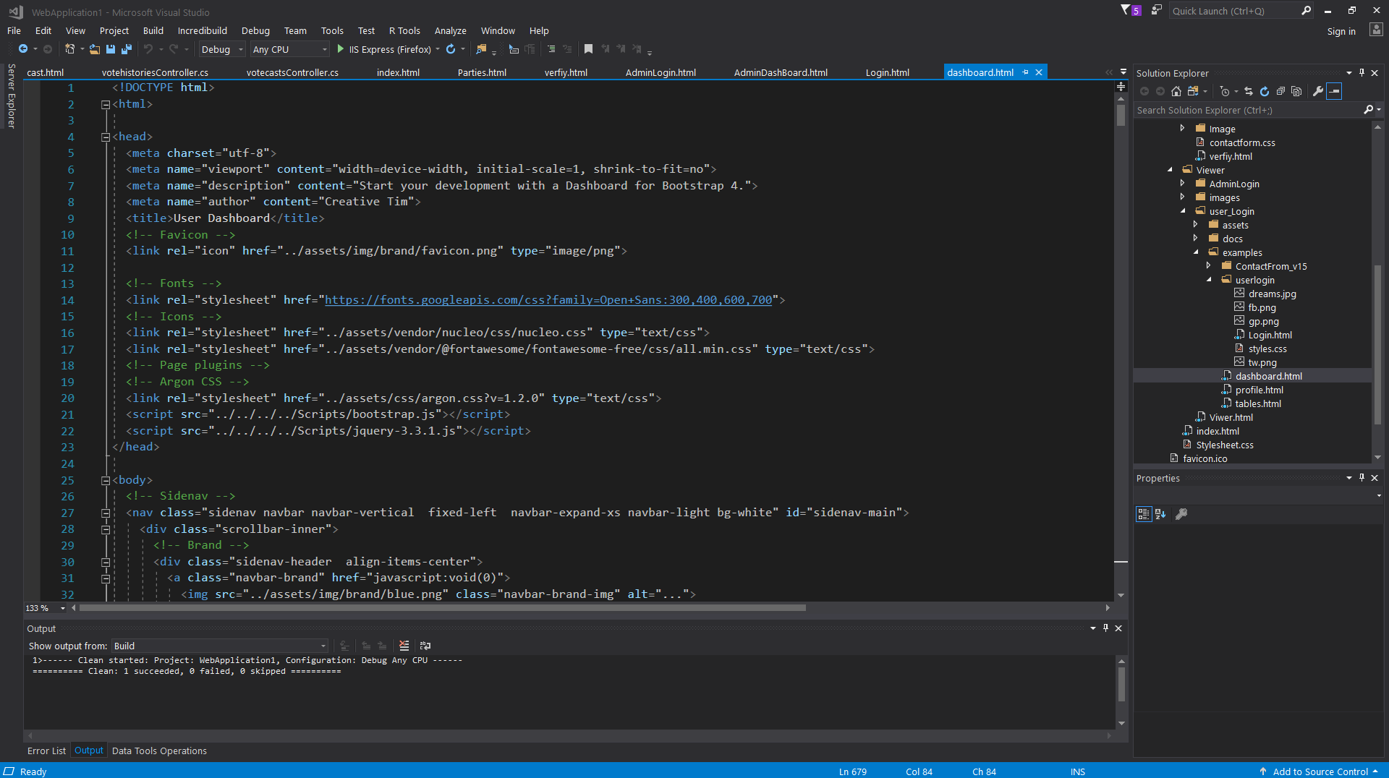

**Figure 9: user dashboard**

# Tables

## Admin Login Table:

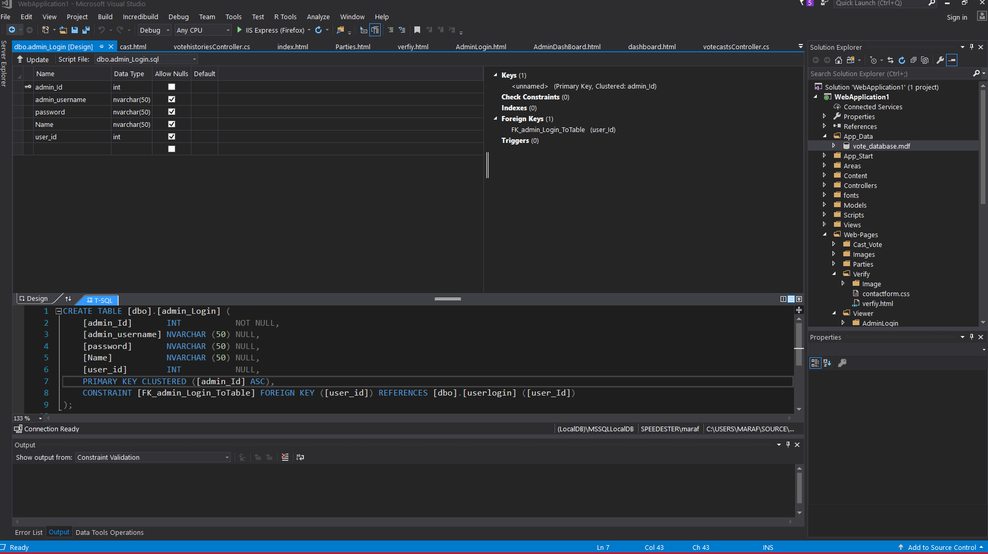

## User Login Table

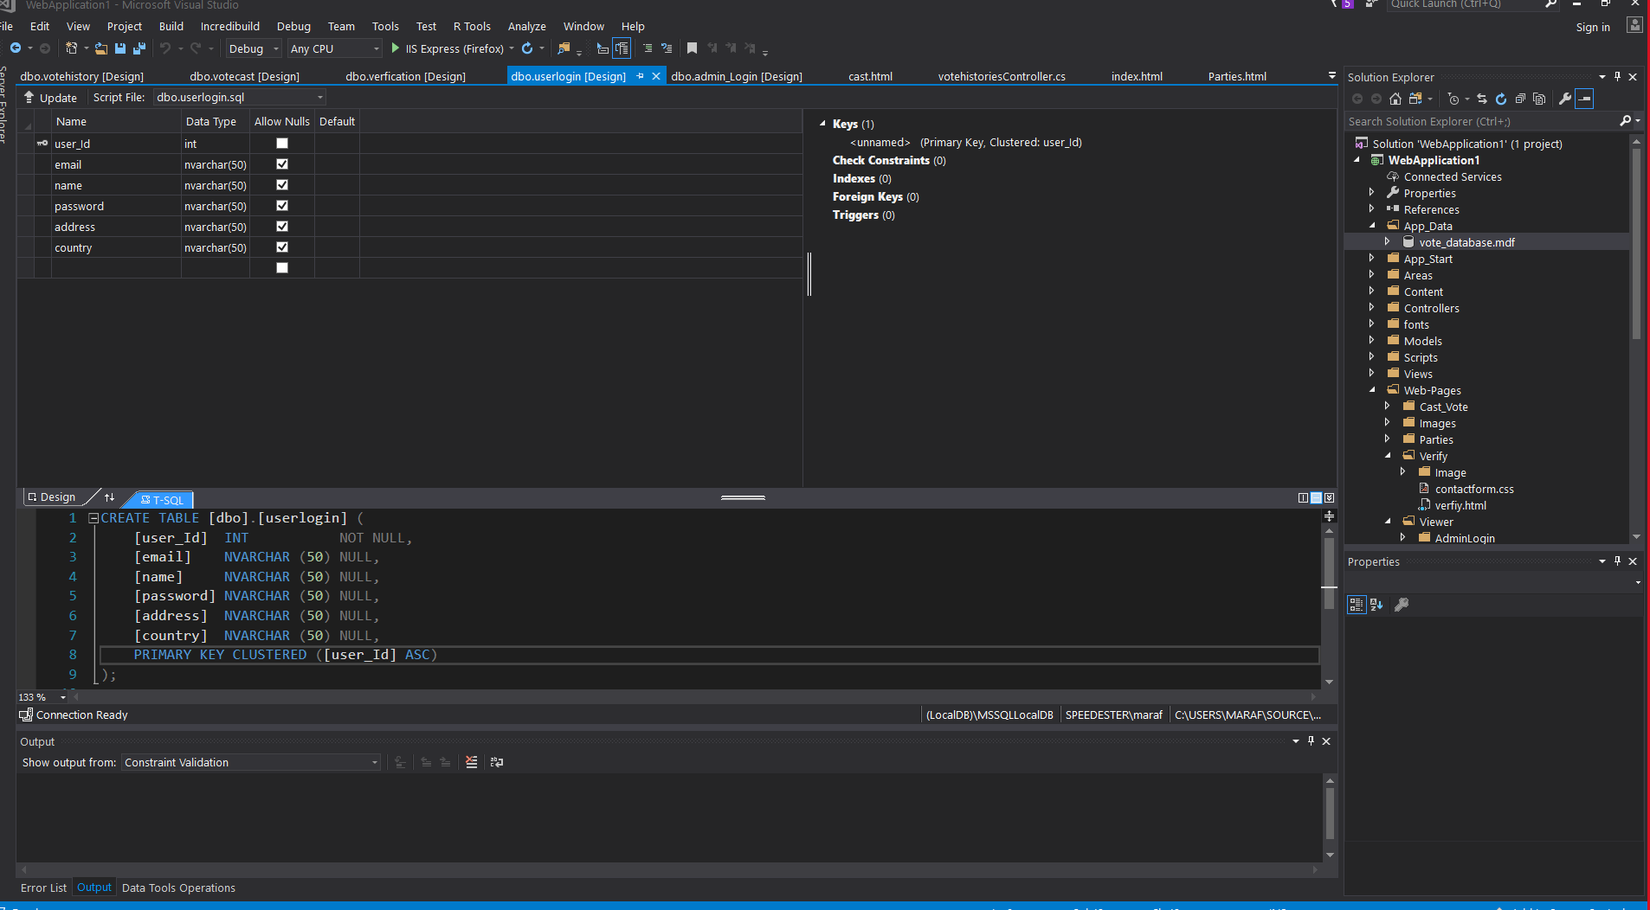

## Cast Vote Table:

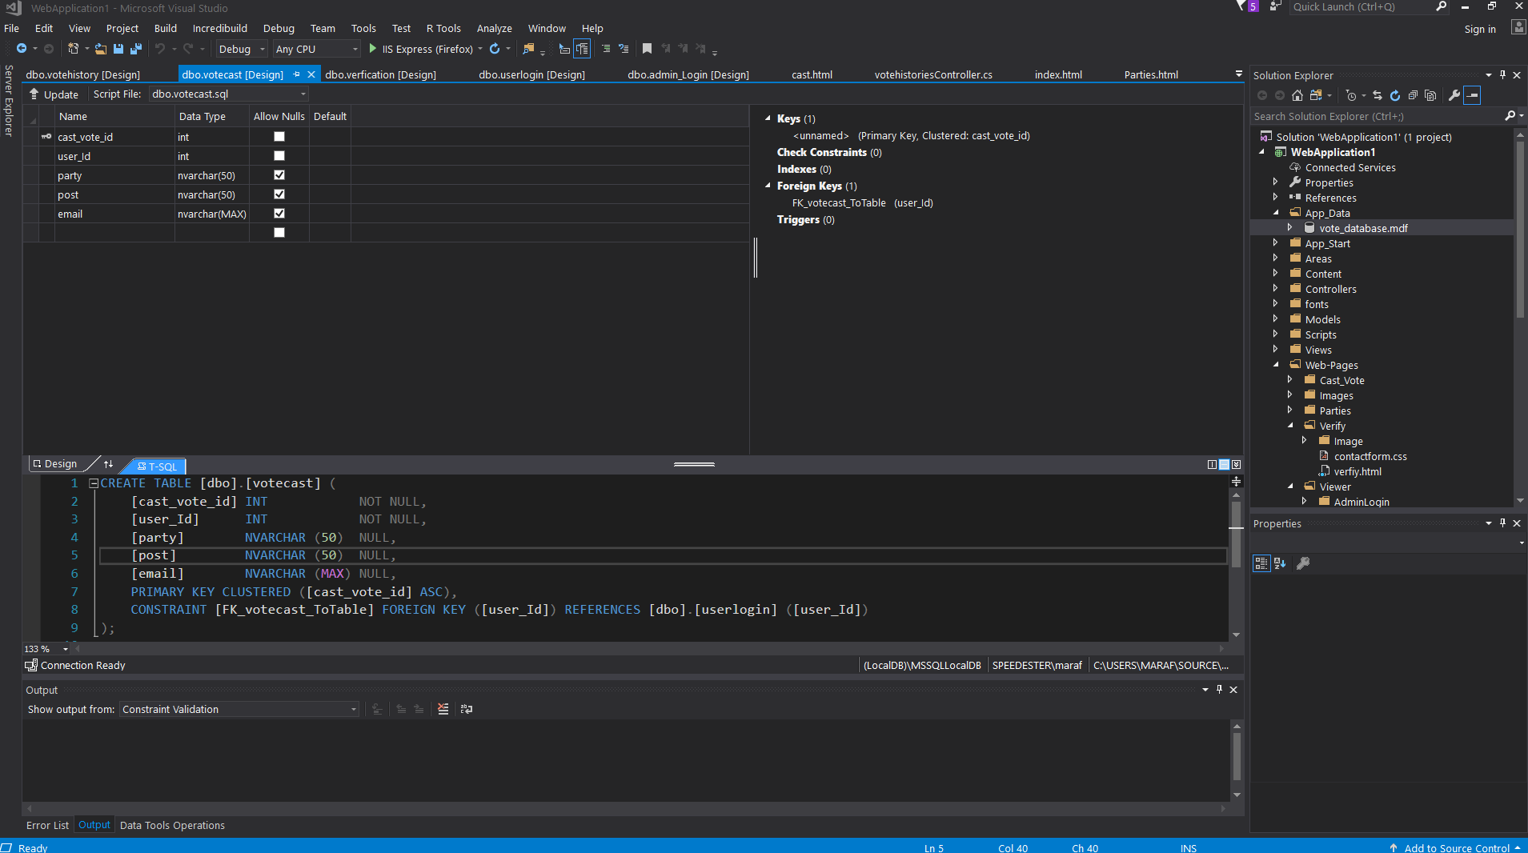

## Vote History Table

